Optimizing LPG Distribution Operational Efficiency through Multi-Tenant Web-Based Information System for Agent Distribution Management

Luthfi Alfaridz ^{a,1,*}, Siti Sarah Abdullah ^{a,2}
ª University of Suryakancana, Jl. Pasirgede Raya, Bojongherang, Cianjur Subdistrict, Cianjur Regency, West Java 43216, Indonesia
¹ luthfifahmi.alv@gmail.com*; ² sarah0040057@gmail.com
* corresponding author

ARTICLE INFO |  | ABSTRACT
Article history  2025/12/28  Revised  Accepted |  | Liquefied Petroleum Gas (LPG) distribution is a critical component of Indonesia's national energy supply chain, with consumption exceeding 8.2 million tons annually. However, many LPG agents continue to rely on manual recording methods, leading to data inaccuracies, order tracking difficulties, and delayed report generation. This study aims to design and implement a web-based LPG distribution management information system utilizing multi-tenant architecture to address operational inefficiencies in LPG agent businesses. The system was developed using the Waterfall methodology with Unified Modeling Language (UML) for system design. The technology stack comprises React 18 for the frontend, NestJS 10 for the backend REST API, and PostgreSQL 15 for database management. Prisma ORM was employed for type-safe database access. Black-box testing was conducted to validate system functionality. The developed system, named SIM4LON, successfully integrates order management, stock tracking, payment processing, and automated reporting within a unified platform. All 28 test cases passed with a 100% success rate, confirming that all functional requirements were met. The multi-tenant architecture effectively isolates data between different retail  outlets (pangkalan) using row-level filtering based on tenant identifiers. The SIM4LON system successfully addresses the identified operational challenges faced by LPG agents. The implementation of modern web technologies combined with multi-tenant architecture provides a scalable, maintainable solution that improves operational efficiency and data accuracy in LPG distribution management
Keywords
Information System
LPG Distribution
Multi-Tenant Architecture
React
NestJS

Introduction
Liquefied Petroleum Gas (LPG) represents one of the most strategically important energy sources widely utilized by Indonesian households and commercial establishments. According to the Ministry of Energy and Mineral Resources (2024), national LPG consumption has reached over 8.2 million tons annually, with an average growth rate of 4-5% each year [1]. Global LPG consumption trends also show steady growth, with the World LPG Association reporting increasing adoption in developing countries [2]. This increasing consumption has driven greater complexity in managing LPG distribution from producers to end consumers.
Indonesia's LPG distribution chain involves several interconnected stakeholders. PT Pertamina, as the producer, supplies LPG to SPBE (Bulk LPG Filling Stations), then agents as authorized distributors collect supplies from SPBE for distribution to retail outlets (pangkalan), which finally sell directly to end consumers [3]. A typical agent manages between tens to hundreds of retail outlets with significant daily transaction volumes, encompassing ordering, delivery, payment, and reporting processes that require systematic management.
Based on the first author's direct experience working at PT Mitra Surya Natasya, an LPG distribution agent in Cianjur Regency, combined with observations conducted during October-November 2025, it was found that most agents still rely on manual recording systems using handwritten ledgers, paper receipts, and unintegrated Excel spreadsheets. This condition creates several significant operational problems. First, stock data inaccuracy frequently occurs because manual recording is prone to input errors and delayed updates, with discrepancies between physical and recorded stock reaching 5-10% monthly. Second, order tracking difficulties make it challenging for operators to monitor delivery status in real-time, resulting in inefficient coordination with drivers. Third, slow report generation causes monthly recapitulation processes to require 3-5 working days. Fourth, data loss risk remains high because paper-based records are susceptible to damage, loss, or illegibility.
Several previous studies have addressed LPG distribution information systems. Dewi et al. (2023) developed a web-based LPG 3 kg sales information system at PT. Nafa Energi Indonesia using PHP and MySQL [4]. Merdekawati et al. (2022) designed an LPG sales information system for retail outlets using the Waterfall methodology [5]. Budianto et al. (2025) implemented distribution requirement planning methods for gas inventory optimization [6]. Furthermore, Made et al. (2025) created a web-based LPG distribution management system using the Laravel framework [7]. However, these studies have not implemented multi-tenant architecture that enables a single system to serve multiple retail outlets with strict data isolation.
Multi-tenant architecture has emerged as a fundamental design pattern in modern Software-as-a-Service (SaaS) applications, allowing multiple customers (tenants) to share a single application instance while maintaining complete data isolation [8]. Recent research by Chowdhury et al. (2024) demonstrates that integrating modern technologies such as IoT and digital platforms can significantly enhance LPG distribution operational efficiency by up to 30% [9]. Additionally, the adoption of cloud-native technologies for multi-tenant SaaS applications has been identified as a best practice for achieving scalability and cost efficiency [10]. Similar integrated information system approaches have been applied in other distribution domains, such as bulk water distribution optimization [11].
This research addresses the identified gap by designing and implementing a web-based LPG distribution management information system called SIM4LON (System Information Management For LPG Online) with multi-tenant architecture. The system employs modern web technologies including React for the frontend user interface, NestJS for the backend API services, and PostgreSQL for data persistence [12], [13], [14]. Recent research on PERN stack development by Smith and Johnson (2023) and Ahmad and Patel (2024) validates the effectiveness of this technology combination for enterprise applications [15], [16]. The multi-tenant approach uses a shared database with shared schema strategy, utilizing `pangkalan_id` as the tenant identifier to ensure data isolation while optimizing resource utilization.
The research objectives are: (1) to design an LPG distribution management information system using UML modeling that accommodates multi-tenant architecture; (2) to implement the system using React 18, NestJS 10, Prisma ORM, and PostgreSQL 15; and (3) to validate system functionality through comprehensive black-box testing.

Methodology
This research employed a qualitative approach to gain a deep, comprehensive understanding of the operational, technological, and managerial complexities within LPG distribution at the agent level. This method was chosen specifically because it allows us to uncover the contextual issues the real-world workflows, challenges, and user requirements that are essential for designing an effective integrated information system. Data collection was conducted through literature review, field observations, and in-depth interviews with stakeholders at an LPG distribution agent in PT Mitra Surya Natasya, Cianjur Regency, West Java, Indonesia. Field observations were carried out during four weeks of operational activities, focusing on ordering, payment, and reporting workflows. In-depth interviews were conducted with 5 key informants: 1 agent owners, 2 administrative staff, and 2 retail outlet (pangkalan) owners. Each interview lasted 15-30 minutes, providing insights into operational challenges, user expectations, and system requirements. System design followed the Waterfall model [17], involving requirement analysis, system design, implementation, testing, and evaluation. This sequential approach was selected because all system requirements were clearly identified through field observations and stakeholder interviews, ensuring systematic progression and traceability between requirements and implemented features. UML diagrams (use case, class, activity, sequence, and entity relationship diagrams) were employed to represent system architecture. Validation was performed using Black Box Testing, covering order management, payment processing, stock tracking, and reporting functions.
The core objective of this study is the development of a proposed integrated information system model, which aims to optimize the entire LPG distribution process. The model focuses on automating critical administrative and operational tasks, including managing payment records, streamlining order, and producing insightful distribution reports all of which are currently pain points for LPG agents relying on manual processes. Building upon this foundation, the conceptual model of our research is structured around three main pillars that interact synergistically to build the integrated information system model like operational factors, technological factors, and managerial factors. This structured approach ensures that the model is not merely a technical solution but a holistic system that addresses the human element and business realities.
- Operational factors
encompass scheduling systems, order management, and customer demand patterns. These components reflect the everyday challenges faced by LPG agents, including managing fluctuating order volumes, prioritizing retail outlet requests, and coordinating limited transportation resources. By mapping these operational elements, the system addresses the practical realities that often cause inefficiencies in LPG distribution.
- Technological factors
Serves as the backbone of process integration, with critical roles played by the central database, automated status tracking mechanisms, responsive web-based interfaces, and the integration of modern development frameworks. Together, these features ensure seamless coordination across processes, reduce redundancy, and enable real-time decision support. The adoption of these information system elements allows agents to minimize errors, accelerate administrative tasks, and improve service reliability.
- Managerial factors
include role-based access control, payment tracking policies, and data security mechanisms. By incorporating these managerial considerations, the model acknowledges that technology alone is insufficient; sustainable success requires appropriate access policies, accountability mechanisms through activity logging, and secure authentication protocols.
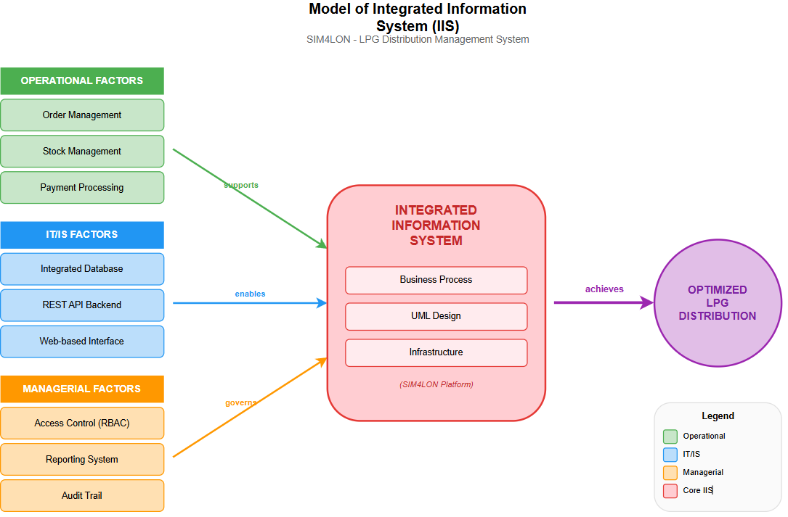
Figure 1 Conceptual Model of SIM4LON for Optimizing LPG Distribution
At the core of the model lies the integrated information system, which connects business processes such as ordering, distribution, payment, and reporting. The system is designed using UML-based diagrams (use case, activity, sequence, and ERD) to ensure clarity, modularity, and maintainability. Hardware, software, and data resources are aligned to support this architecture, enabling the organization to achieve optimized LPG distribution. Ultimately, the model demonstrates how the interplay of operational needs, technological solutions, and managerial strategies can be harmonized into a single integrated system. Its goal is not only to streamline routine administrative tasks but also to enhance the overall performance of the distribution process, reduce costs, and provide reliable service to retail outlets.
  - Development Tools
The development environment utilized the following technology stack as shown in Table 1.
Table 1 Software Development Tools
Category | Tool | Version | Function
IDE | VS Code | 1.85 | Code editor
Frontend Framework | React | 18.2 | UI library
Build Tool | Vite | 5.0 | Frontend bundler
CSS Framework | Tailwind CSS | 3.4 | Utility-first styling
UI Components | Shadcn/UI | Latest | Accessible component library
Backend Framework | NestJS | 10.2 | REST API framework
ORM | Prisma | 5.7 | Type-safe database access
Database | PostgreSQL | 15 | Relational data storage
UML Tool | PlantUML | Latest | UML diagram generation
Frontend Hosting | Vercel | - | Static site deployment
Backend Hosting | Railway | - | Container deployment
File Storage | Supabase Storage | - | Cloud file management
  - Research Stages
The research followed the Waterfall methodology stages [18]:

Requirements Analysis (October 2025)
Conducted stakeholder interviews and field observations to identify functional and non-functional requirements. Documented requirements in structured format with acceptance criteria.

System Design (November-December 2025)
Created comprehensive UML documentation including Use Case Diagrams (18 use cases, 3 actors), Class Diagrams (23 classes, 7 enumerations), Activity Diagrams (25 diagrams for core processes), Sequence diagrams (18 diagrams for use case interactions), State Machine Diagrams (4 diagrams), and Entity Relationship Diagrams (23 tables). Additionally, designed the user interface wireframes and system architecture.

Implementation (November-December 2025)
Developed the system following the designed specifications. Frontend development used React with TypeScript, implementing responsive design patterns. Backend development utilized NestJS with modular architecture, implementing RESTful APIs with JWT authentication.

Testing (December 2025)
Conducted black-box testing with 28 test cases covering all functional requirements. Documented test results and performed bug fixes as necessary.

Deployment (December 2025)
Deployed the frontend to Vercel and backend to Railway with PostgreSQL database. Configured production environment variables and verified system accessibility.
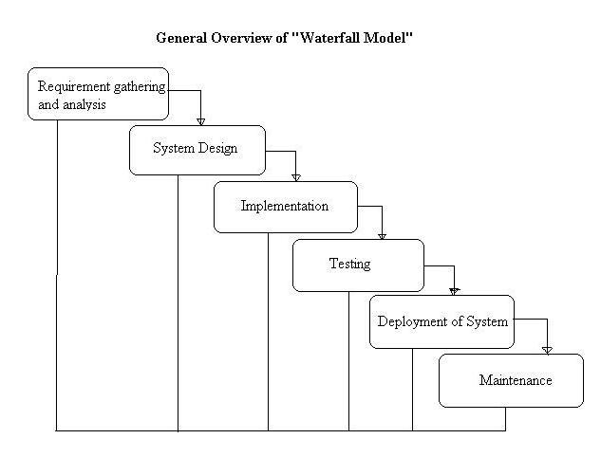
Figure 2 Waterfall Methodology Implementation Stages [18]
  - Data Analysis Techniques
System validation was performed using black-box testing methodology, which focuses on testing system functionality without examining internal code structure [19], [20]. Test cases were designed based on functional requirements, with each test case specifying input data, expected output, and pass/fail criteria. The test coverage included authentication (5 tests), order management (8 tests), payment processing (5 tests), stock management (6 tests), and reporting (4 tests).
The success rate was calculated using the formula:
Success Rate (%) = (Number of Passed Tests / Total Test Cases) × 100
A minimum success rate of 100% was required before deployment to ensure all functional requirements were met.

Results and Discussion

Presentation of Research Results

Current System Analysis
The existing LPG agent business process operates entirely through manual methods. Retail outlets place
orders via WhatsApp messages or phone calls to operators. Operators manually record orders in handwritten
ledgers, then verbally assign drivers for delivery. Payments are separately recorded in cash books, and
monthly reports are compiled manually using Excel spreadsheets. This workflow is illustrated in Figure 2.
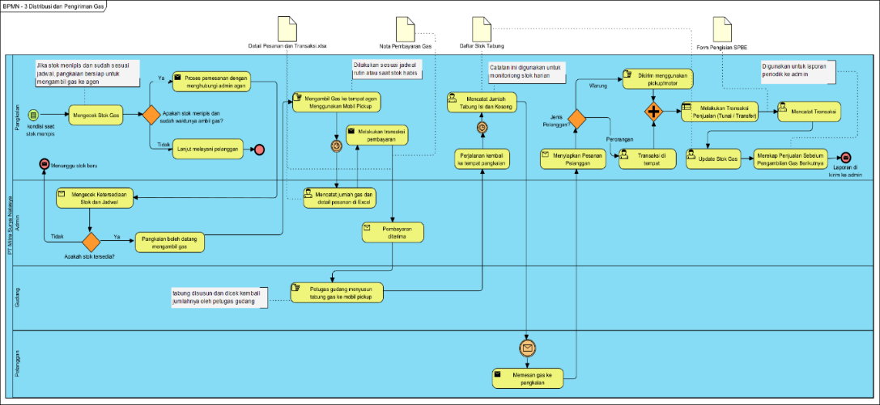
Figure 3 Business Process Model of Current Manual System
The analysis identified the following critical issues: (1) no integration between order recording and payment systems; (2) high susceptibility to human error in manual data entry; (3) inability to monitor delivery status in real-time; (4) time-consuming monthly report generation requiring 3-5 working days.

Requirements Specification
Table 2 Functional and Non-Functional Requirements
Functional Requirements | Non-Functional Requirements
The system shall manage user accounts with role-based access control (Admin, Operator, Pangkalan) | Web-based responsive design accessible on desktop and mobile browsers
The system shall manage retail outlet (pangkalan) and driver master data | JWT-based authentication with single-session login enforcement
The system shall create, update, and track order status through lifecycle | Support to 100 retail outlets per agent
The system shall record payments including down payments and installments | Response time under 3 seconds for standar operations
The system shall track stock movements (incoming from SPBE, outgoing to retail outlets)
The system shall generate reports in PDF and Excel formats

System Design

Use Case Diagram
Figure 3 presents the complete use case diagram showing 18 identified use cases and 3 actor types. The Admin actor has full system access, the Operator handles daily operations, and the Pangkalan (retail outlet) actor has limited access to their own data through the multi-tenant isolation mechanism.
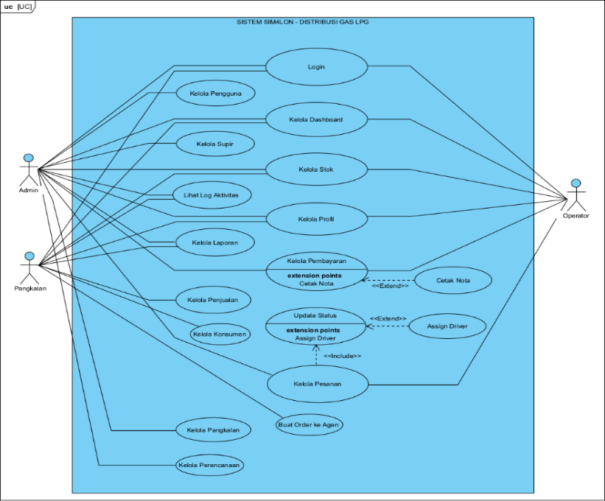
Figure 4 SIM4LON Use Case Diagram
The 18 identified use cases are organized by actor role. Admin-exclusive use cases include user management and product configuration. Operator use cases encompass order creation and tracking, payment recording, stock management, and report generation. Pangkalan use cases enable retail outlets to view their orders and payments, and manage their consumer transactions within the multi-tenant data isolation framework.

Activity Diagram
Figure 5 illustrates the order creation workflow. The process begins when a user opens the order page and clicks "Create New Order”.
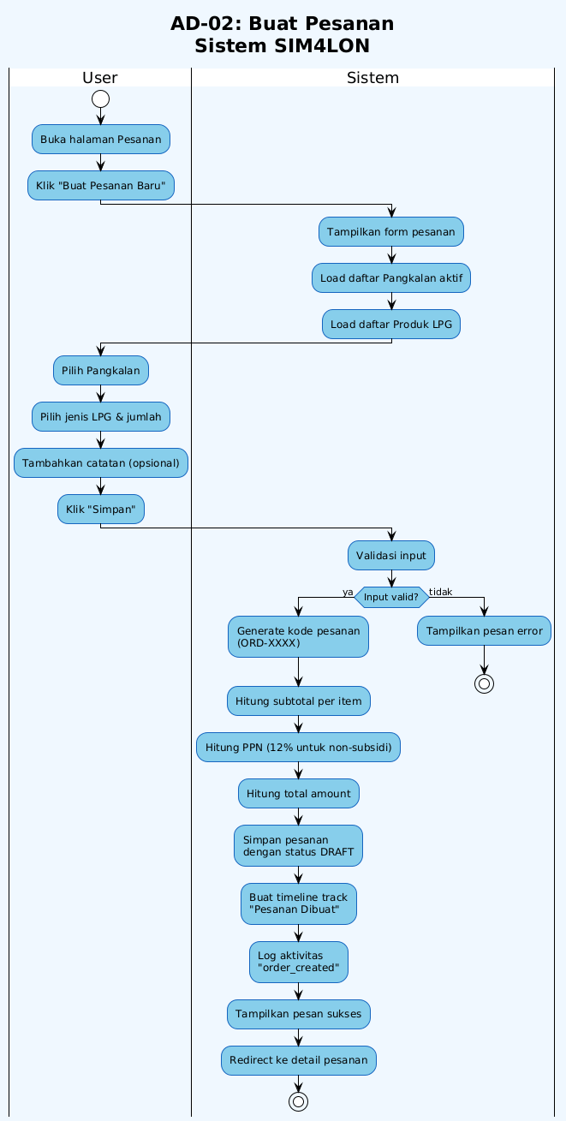
Figure 5 Create Order
The system displays the order form and loads active Pangkalan list along with LPG products. The user selects Pangkalan, chooses LPG type and quantity, adds optional notes, and clicks save.

Sequence Diagram
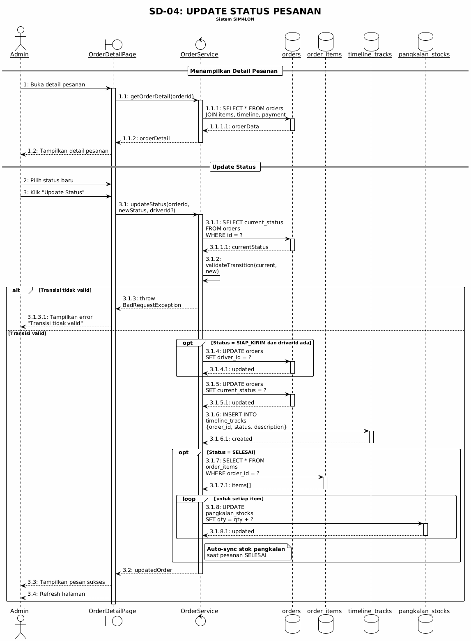
Figure 6 Update Order Status Process
The diagram demonstrates the communication flow between Admin, OrderDetailPage, OrderService, and database tables (orders, order_items, timeline_tracks, pangkalan_stocks). Key processes include status transition validation, driver assignment for SIAP_KIRIM status, and automatic stock synchronization to pangkalan when order status becomes SELESAI.

Entity Relationship Diagram
Figure 4 displays the database schema comprising 23 core tables implementing the multi-tenant data model.
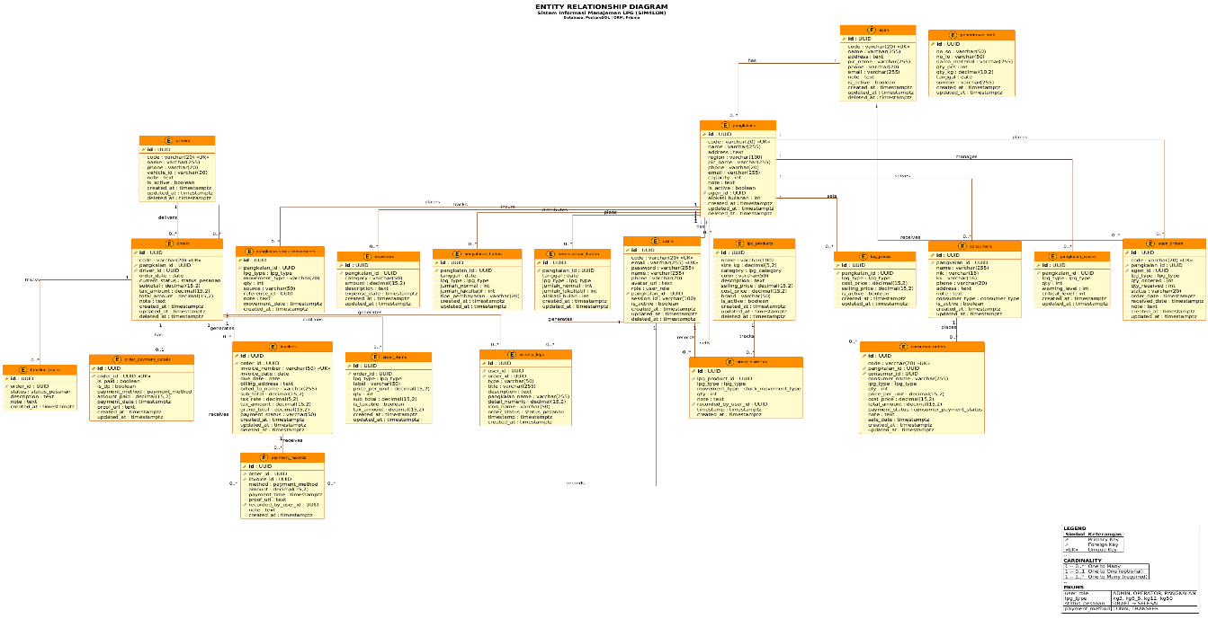
Figure 7 Entity Relationship Diagram

State Machine Diagram
Orders begin in DRAFT state upon creation, then transition through MENUNGGU_PEMBAYARAN (Awaiting Payment), DIPROSES (Processing), SIAP_KIRIM (Ready to Ship), DIKIRIM (Shipped), and finally SELESAI (Completed). The BATAL (Cancelled) state serves as a terminal state accessible from any state except SELESAI. Notably, when an order reaches SELESAI status, the system automatically synchronizes stock to the pangkalan's inventory.
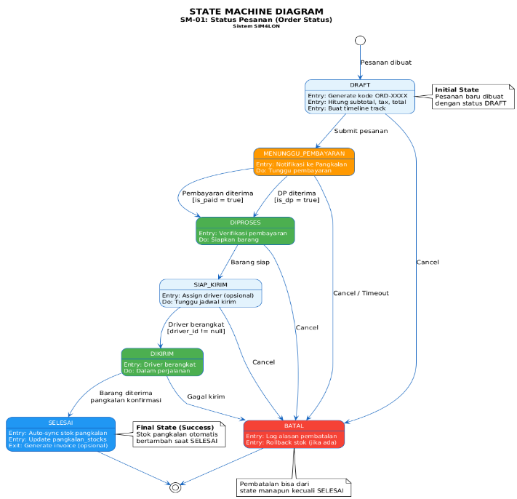
Figure 8 State Machine Diagram Order Status Lifecycle

System Implementation
The system architecture follows a three-tier pattern [21]: (1) Presentation Layer using React application hosted on Vercel with responsive design; (2) Business Logic Layer using NestJS application on Railway implementing modular service architecture with dedicated modules for authentication, users, orders, payments, stock, and reporting; and (3) Data Layer using PostgreSQL database with Supabase Storage for file uploads. User interface screenshots are presented in Figures 8-11, demonstrating the key functional interfaces of the SIM4LON system.

Login Page
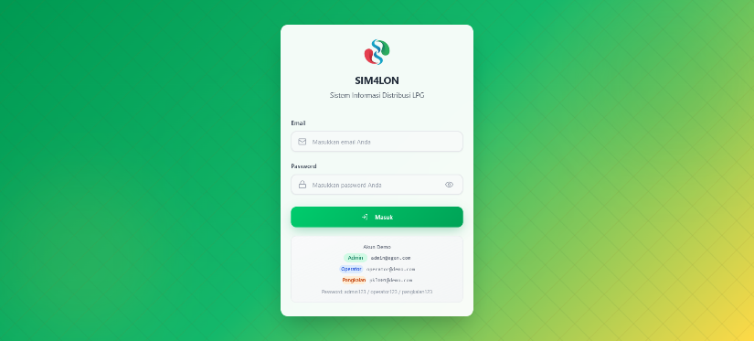
Figure 9 Login Page Interface

Dashboard
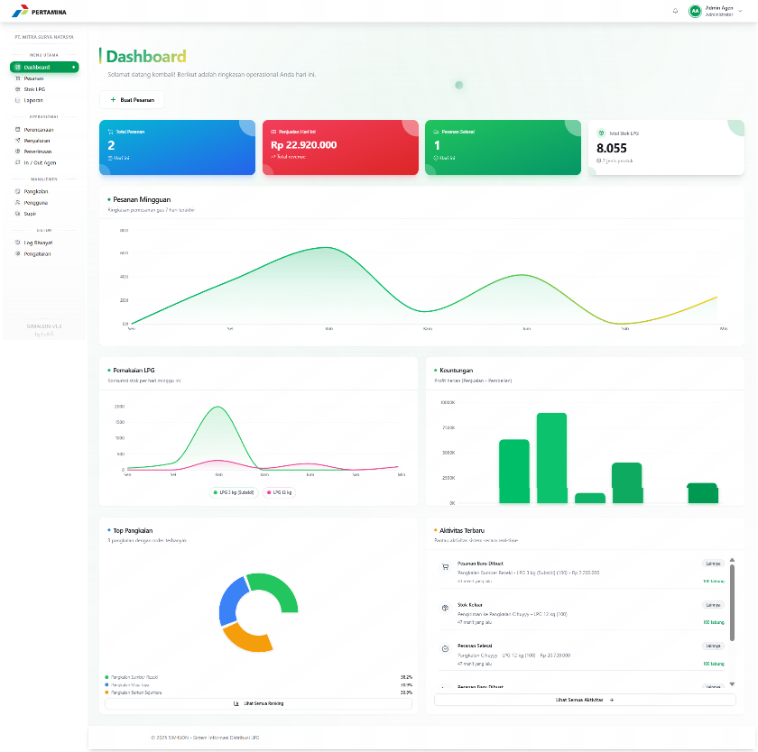
Figure 10 Dashboard Interface

Order Management
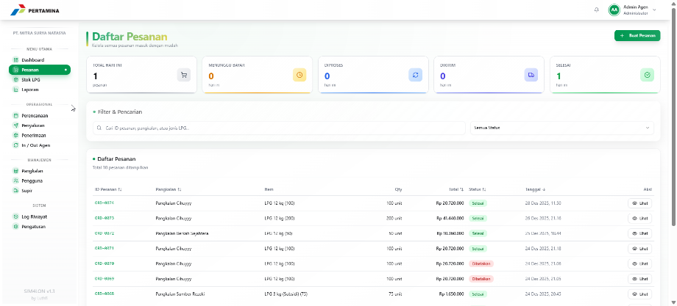
Figure 11 Order Management Interface

Create Order Form
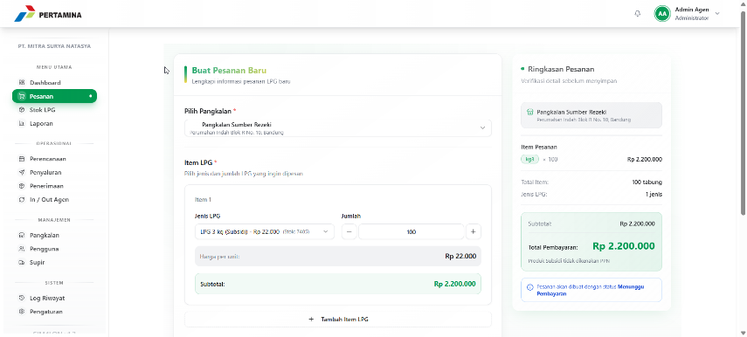
Figure 12 Create Order Interface

Detail Order
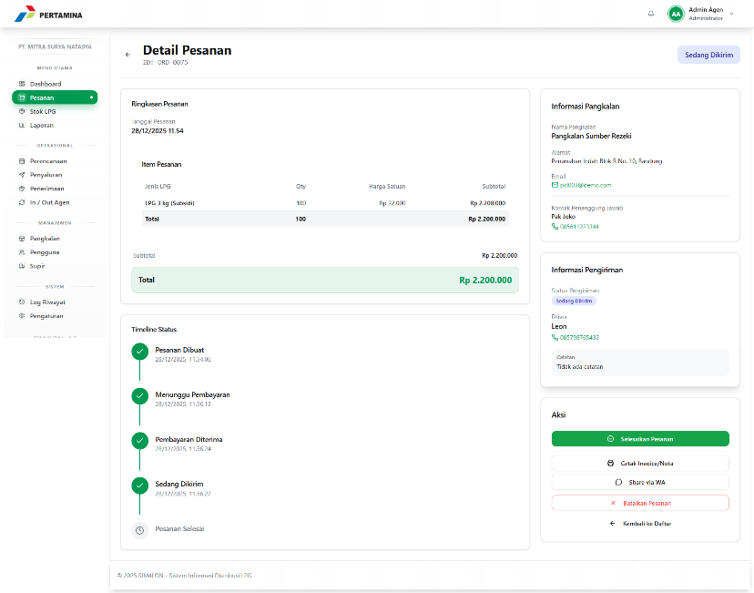
Figure 13 Order Detail Interface

Stock Management

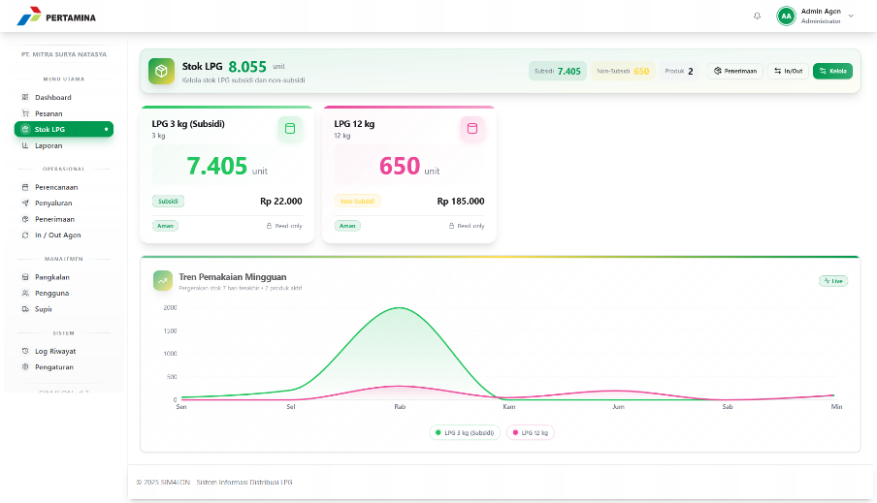
Figure 14 Stock LPG Management Interface

System Testing
Black-box testing was conducted across all functional modules. Table 2 presents sample test cases, and Table 3 summarizes the testing results.
Table 3 Sample Black-Box Test Cases
ID | Module | Test Case | Input | Expected Output | Result
TC01 | Auth | Valid Login | Correct credentials | Dashboard redirect | Pass
TC02 | Auth | Invalid Login | Wrong password | Error message | Pass
TC03 | Auth | Session Expiry | Expired JWT | Auto logout | Pass
TC04 | Auth | Single Session | New device login | Previous session terminated | Pass
TC05 | Order | Create Order | Valid order data | Order created | Pass
TC06 | Order | Empty Order | No items | Validation error | Pass
TC07 | Order | Status Update | New status | Status changed | Pass
TC08 | Order | Driver Assignment | Select driver | Driver assigned | Pass
TC09 | Payment | Record DP | Down payment | Payment recorded | Pass
TC10 | Stock | Record Incoming | Stock addition | Balance updated | Pass

Table 4 Testing Result Summary
Category | Test Case | Passed | Failed | Success Rate
Authentication | 5 | 5 | 0 | 100%
Order Management | 8 | 8 | 0 | 100%
Payment Processing | 5 | 5 | 0 | 100%
Stock Management | 6 | 6 | 0 | 100%
Reporting | 4 | 4 | 0 | 100%
Total | 28 | 28 | 0 | 100%

Analysis of Findings
The testing results demonstrate that SIM4LON successfully meets all defined functional requirements with a 100% test case pass rate. The system effectively addresses the operational challenges identified during the requirements analysis phase. Order processing becomes streamlined through the status-tracking mechanism, allowing real-time visibility of delivery progress. Payment integration eliminates the need for separate cash book records, ensuring accurate receivables tracking.
The multi-tenant implementation using shared database with shared schema proves effective for this use case. Data isolation through `pangkalan_id` filtering prevents unauthorized access between retail outlets while maintaining a single database instance for operational efficiency. This finding aligns with recommendations from contemporary multi-tenant architecture research [8], [10], [22].
The technology stack selection of React, NestJS, and PostgreSQL demonstrates suitability for developing scalable web applications. React's component-based architecture enables efficient UI development, NestJS provides structured backend organization through its modular design, and PostgreSQL's ACID compliance ensures transactional data integrity critical for financial record-keeping.
Comparing with previous LPG distribution systems [4], [5], [6], [7], the SIM4LON implementation provides several advancements: (1) modern JavaScript/TypeScript stack replacing legacy PHP implementations; (2) multi-tenant architecture enabling single-deployment multi-client support; (3) cloud-native deployment eliminating on-premise infrastructure requirements; and (4) comprehensive UML documentation facilitating maintainability.

Implications of the Result
From a practical perspective, the system brings noticeable improvements to daily operations. Agents can now process orders faster since everything is recorded digitally instead of handwritten ledgers. Stock tracking becomes more reliable because the system updates automatically when orders are completed. What used to take 3-5 days for monthly reports can now be generated instantly. The driver assignment feature also helps coordinate deliveries better than verbal communication. On the theoretical side, this work shows that multi-tenant architecture can work well for small-to-medium distribution businesses in Indonesia. The combination of React and NestJS proves to be a viable choice for building enterprise-level applications that handle financial transactions. Other researchers working on similar distribution systems may find this implementation useful as a reference.

Limitations of the Study
This study has several limitations worth noting. We only performed black-box testing to verify that features work as expected, but did not conduct unit tests or load testing. This means we cannot fully guarantee code quality or how the system behaves under heavy usage. Security was another area we did not explore deeply. While basic JWT authentication is in place, we did not perform penetration testing or implement advanced protections like rate limiting. We also did not conduct formal usability testing with actual users, so user satisfaction remains unmeasured.
The system was tested with sample data rather than real production volumes. How it performs with over 100 retail outlets making concurrent requests is still uncertain. Additionally, the system requires internet connectivity to function, which may be problematic in areas with unreliable networks. Future work should address these gaps through proper security audits, usability studies with actual users, and performance testing with realistic data volumes.

Conclusion
This study successfully designed and implemented SIM4LON, a web-based LPG distribution management system with multi-tenant architecture. The system was developed using React 18, NestJS 10, Prisma ORM, and PostgreSQL 15, and deployed on cloud infrastructure (Vercel and Railway). Black-box testing with 28 test cases achieved a 100% success rate (28/28 passed), confirming all functional requirements were met. The system addresses the operational inefficiencies identified in the introduction. The integration of order management, stock tracking, payment processing, and automated reporting into a unified platform reduces manual recording errors that previously caused 5-10% monthly stock discrepancies. Furthermore, the automated report generation feature eliminates the 3-5 working days required for manual monthly recapitulation, representing a significant reduction in administrative workload. The multi-tenant architecture successfully isolates data across retail outlets using `pangkalan_id` as tenant identifier, enabling a single system instance to serve multiple pangkalan with complete data separation. In summary, combining modern web technologies with multi-tenant architecture provides a practical and scalable solution for improving operational efficiency in LPG distribution management.

Acknowledgment
The authors express gratitude to PT Mitra Surya Natasya and the retail outlet owners in Cianjur Regency who participated in interviews and provided insights into their operational challenges.

Declarations
Author contribution. The first author was designed the system requirements based on firsthand operational experience, developed the system, and wrote the manuscript. The second author was supervised the research methodology and reviewed the manuscript.
Funding statement. This research received no external funding
Conflict of interest. The first author is employed at PT Mitra Surya Natasya, the LPG distribution agent that served as the case study for this research. This involvement provided valuable operational insights but does not affect the objectivity of the research findings.
Additional information. No additional information is available for this paper.

Data and Software Availability Statements
The SIM4LON system is deployed and accessible at:
- Frontend: https://sim4lon.vercel.app
- Backend API: Hosted on Railway platform

Source code is available in a private repository. Access may be granted upon reasonable request to the corresponding.

References
[1] Pertamina, “Penyaluran LPG 3 Kg Tembus 8,2 Juta Ton pada 2024,” Kontan. Accessed: Dec. 26, 2025. [Online]. Available: https://industri.kontan.co.id/news/pertamina-penyaluran-lpg-3-kg-tembus-82-juta-ton-pada-2024
[2] W. W. Org, “STATISTICAL REVIEW OF GLOBAL LPG 2020,” 2023. Accessed: Dec. 28, 2025. [Online]. Available: https://www.smf.com.sg/wp-content/uploads/2024/07/WLPGA-Statistical-Review-2023.pdf
[3] BPH Migas, “Pedoman Distribusi LPG Tabung di Indonesia.” Accessed: Dec. 26, 2025. [Online]. Available: https://migas.esdm.go.id/post/menteri-esdm-tetapkan-kepmen-esdm-tentang-petunjuk-teknis-pendistribusian-isi-ulang-lpg-tertentu-tepat-sasaran
[4] A. F. Dewi, R. M. Ghozali, and D. K. Budiono, “RANCANG BANGUN SISTEM INFORMASI PENJUALAN GAS LPG 3 KG DI PT. NAFA ENERGI INDONESIA BOTOLINGGO, BONDOWOSO,” 2023. [Online]. Available: www.jurnal.itsm.ac.id
[5] A. Merdekawati, J. T. Kumalasari, and T. A. Salsabila, “Rancang Bangun Sistem Informasi Penjualan Pada Pangkalan Gas Elpiji Dengan Implementasi Metode Waterfall,” Jurnal Nasional Komputasi dan Teknologi Informasi, vol. 5, no. 6, 2022.
[6] H. Budianto, F. F. Z. Mustaqin, E. I. Setiawan, and J. Santoso, “Optimization of LPG Distribution for a Multiplatform-Based LPG Marketplace,” International Journal of Engineering, Science and Information Technology, vol. 5, no. 3, pp. 327–336, Jul. 2025, doi: 10.52088/ijesty.v5i3.994.
[7] I. Made et al., “Perancangan Sistem Informasi Eksekutif Penjualan Pada Pangkalan Gas LPG I Made Muliawan Berbasis Website Menggunakan Framework Laravel (I Made Andi Arsana) Perancangan Sistem Informasi Eksekutif Penjualan Pada Pangkalan Gas LPG I Made Muliawan Berbasis Website Menggunakan Framework Laravel,” vol. 2, no. 1, p. 2025, 2025.
[8] Shinu Pushpan, “Multi-Tenant Architecture: A Comprehensive Framework for Building Scalable SaaS Applications,” International Journal of Scientific Research in Computer Science, Engineering and Information Technology, vol. 10, no. 6, pp. 1117–1126, Nov. 2024, doi: 10.32628/cseit241061151.
[9] A. Chowdhury, S. K. Shil, Z. Eusufzai, and S. M. Mobin, “Digital Transformation In The LPG Industry: Leveraging IoT And Data Analytics For Operational Efficiency,” ACADEMIC JOURNAL ON SCIENCE, TECHNOLOGY, ENGINEERING & MATHEMATICS EDUCATION, vol. 1, no. 01, pp. 131–144, Oct. 2024, doi: 10.69593/ajieet.v1i01.144.
[10] R. Kumar, “Multi-Tenant SaaS Architectures: Design Principles and Security Considerations THIS IS A LEVEL 1 HEADING,” Quest Journals Journal of Architecture and Civil Engineering, vol. 5, no. 2, pp. 2321–8193, 2020, doi: 10.35629/8193-05024962.
[11] S. S. Abdullah and T. R. Sumirat, “An Integrated Information System Model for Optimizing Bulk Water Distribution,” Media Jurnal Informatika, vol. 17, no. 1a, 2025.
[12] Inc. Meta Platforms, “React Documentation: A JavaScript Library for Building User Interfaces.” Accessed: Dec. 26, 2025. [Online]. Available: https://react.dev
[13] NestJS Contributors, “NestJS Documentation: A Progressive Node.js Framework.” Accessed: Dec. 26, 2025. [Online]. Available: https://docs.nestjs.com
[14] PostgreSQL Global Development Group, “PostgreSQL 15 Documentation.” Accessed: Dec. 28, 2025. [Online]. Available: postgresql.org/docs/16.
[15] B. Bachina, “Available online www,” jsaer.com Journal of Scientific and Engineering Research 189 Journal of Scientific and Engineering Research, vol. 2023, no. 2, pp. 189–201, Accessed: Dec. 28, 2025. [Online]. Available: https://jsaer.com/download/vol-10-iss-2-2023/JSAER2023-10-2-189-201.pdf
[16] V. Sahni, A. Chopde, M. Goswami, and A. Kumar, “Mern(Mongodb , Express-Js, React-Js, Node-Js) Stack Web-Based Themefied Education Platform For Placement Preparation,” Educational Administration: Theory and Practice, 2024, doi: 10.53555/kuey.v30i5.3035.
[17] R. S. Pressman and B. R. Maxim, Software Engineering: A Practitioner’s Approach, 9th ed. New York: McGraw-Hill Education, 2020.
[18] Tryqa, “What is Waterfall model- Examples, advantages, disadvantages & when to use it.” Accessed: Dec. 28, 2025. [Online]. Available: https://tryqa.com/what-is-waterfall-model-advantages-disadvantages-and-when-to-use-it/
[19] K. Naik and P. Tripathy, Software Testing and Quality Assurance: Theory and Practice, 2nd ed. Hoboken, NJ: Wiley, 2021.
[20] A. Bhanushali, “Ensuring Software Quality Through Effective Quality Assurance Testing: Best Practices and Case Studies,” 2023. [Online]. Available: https://www.researchgate.net/publication/375342628_Ensuring_Software_Quality_Through_Effective_Quality_Assurance_Testing_Best_Practices_and_Case_Studies
[21] F. Al-Hawari, A. Alufeishat, M. Alshawabkeh, H. Barham, and M. Habahbeh, “The Software Engineering of a Three-Tier Web-Based Student Information System (MyGJU).”
[22] Rishi Kumar Sharma, “Multi-Tenant Architectures in Modern Cloud Computing: A Technical Deep Dive,” International Journal of Scientific Research in Computer Science, Engineering and Information Technology, vol. 11, no. 1, pp. 307–317, Jan. 2025, doi: 10.32628/cseit25111236.

